

**Title**

**Bachelor-/Master thesis**

At the Institute for Entrepreneurship, Technologie-Management and Innovation (EnTechnon)

For the acquisition of the academic degree

**Bachelor / Master of Science (B./M.Sc.)**

**in Industrial Engineering and Management**

By: Name, Surname

Matriculation no.: XXXXXX

Examiner: Prof. Dr. Orestis Terzidis

Supervisor:

The citation format that should be used to cite sources is APA.

**Table of Contents**

List of figures 2

List of tables 3

List of abbreviations 4

1 Introduction 5

2 Chapter heading 6

References 7

Appendix 8

Statutory declaration 9

**List of figures**

Figure 1: Title Figure 1 5

Figure 2: Title figure 2 6

**List of tables**

Tabelle 1: Titel Tabelle 1 5

**List of abbreviations**

EE Entrepreneurship-Education

EPFL École Polytechnique Fédérale de Lausanne

FGF Förderkreis Gründungs-Forschung e.V.

GR Graduate

# Introduction

Agnisim ad te diamcon sectet, voloborper aciduis nonsequamet, sequis-ciduis nonum irilit ea feugait, sequat vero er ip exero odipit lobore magnit nos nibh ex esed exerciduisi tat. Consed et inci tet aci et atem in ut velenim vent ullum exeril ut laore molorpe riliscidunt la con ulputat ad digna feum quismolesto dolortisl ea feuguercil delit praessim ver ad tem ipit, velit, conse enis nonsed mod tincipit augue veniametuer aut vulput nonsed molesse miniatuercin hendit in henibh etumsan velessi.

|  |  |  |  |  |  |
| --- | --- | --- | --- | --- | --- |
|  | **KEAfossil** | **Emissionen** | | | |
|  |  | **CO** | **NOx** | **SO2** | **CO2,fossil** |
| Einheit | MWh/MWh | Kg/MWh | Kg/MWh | Kg/MWh | Kg/MWh |
| Steinkohle (D) | 1,06 | 0,010 | 0,046 | 0,062 | 16,9 |
| Heizöl EL | 1,11 | 0,035 | 0,107 | 0,182 | 29,5 |
| Heizöl S | 1,15 | 0,036 | 0,106 | 0,197 | 38,5 |
| Erdgas (D) | 1,07 | 0,050 | 0,045 | 0,047 | 9,85 |

**Table 1: Title Table 1**

It verilluptat adiatie vel ullum il dolorem zzriuscing et pratinit wis acilismodit adions ad magna autat ulput adip eum do eu faci tem ver ipis at augue ming erit wiscillan hent iliquisl ullam ecte delent ent adiam zzrit aliqui tie volorem inibh essequip enis nullaore vent ametum vullam, velese vullametue verit, sit ex er il ute dolortio commy nos el utat.

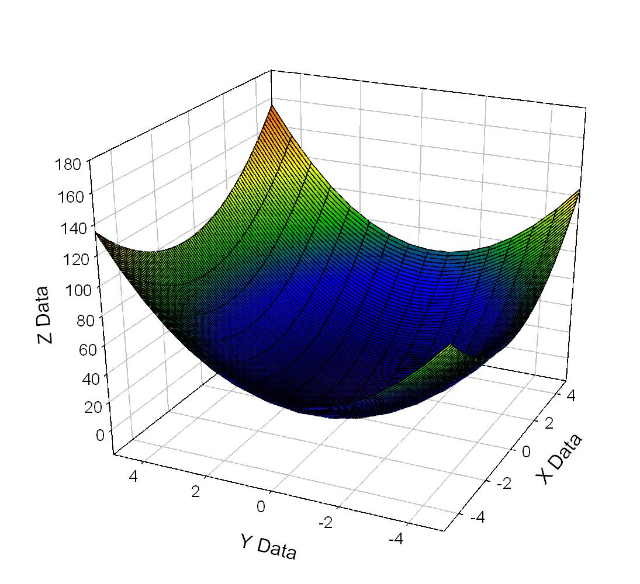

**Figure 1: Title Figure 1**

# Chapter heading

Agnisim ad te diamcon sectet, voloborper aciduis nonsequamet, sequis-ciduis nonum irilit ea feugait, sequat vero er ip exero odipit lobore magnit nos nibh ex esed exerciduisi tat. Consed et inci tet aci et atem in ut velenim vent ullum exeril ut laore molorpe riliscidunt la con ulputat ad digna feum quismolesto dolortisl ea feuguercil delit praessim ver ad tem ipit, velit, conse enis nonsed mod tincipit augue veniametuer aut vulput nonsed molesse miniatuercin hendit in henibh etumsan velessi.

It verilluptat adiatie vel ullum il dolorem zzriuscing et pratinit wis acilismodit adions ad magna autat ulput adip eum do eu faci tem ver ipis at augue ming erit wiscillan hent iliquisl ullam ecte delent ent adiam zzrit aliqui tie volorem inibh essequip enis nullaore vent ametum vullam, velese vullametue verit, sit ex er il ute dolortio commy nos el utat.

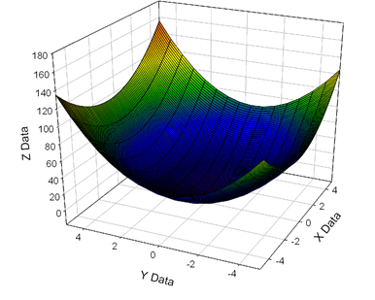

**Figure 2: Title figure 2**

Nons dolore voloborper sed magnit enisisi. Onsenit digna facip ex eraestin ulla consequatie do cons nulla feugiat. Bor irilla feuguer cipsum er autpat. Duis ad minciliquat. Er sis autat ut wis dolorper adion hendre ver sequate molore etuerci exeros nonulla consectet lorpera essequiscip ectet, suscil el utpat luptatum velis nulla.

**References**

Maurya, A. (2012), *Running lean: Iterate from plan A to a plan that works,* 2nd ed., O'Reilly, Sebastopol, CA.

Morris, C.R. and Ferguson, C.H. (1993), “How architecture wins technology wars”, *Harvard Business Review*, Vol. 71 No. 2, pp. 86–96.

Osterwalder, A., Pigneur, Y. and Clark, T. (2010), *Business model generation: A handbook for visionaries, game changers, and challengers*, Wiley, Hoboken, NJ.

Pahl, G., Beitz, W., Feldhusen, J. and Grote, K.-H. (2006), *Pahl/Beitz Konstruktionslehre: Grundlagen erfolgreicher Produktentwicklung. Methoden und Anwendung,* 7th ed., Springer, Berlin.

Ries, E. (2011), *The lean startup: How today's entrepreneurs use continuous innovation to create radically successful businesses,* 1st ed., Crown Business, New York.

Saunders, M., Lewis, P. and Thornhill, A. (2012), *Research methods for business students,* 6th ed., Pearson, Harlow, England; New York.

Schilling, M.A. (2008), *Strategic management of technological innovation,* 2nd ed., McGraw-Hill/Irwin, Boston.

Tellis, W. (1997), “Introduction to Case Study”, The Qualitative Report, available at: http://www.nova.edu/ssss/QR/QR3-2/tellis1.html (accessed 18 January 2013).

**Appendix**

**Statutory declaration**

I herewith declare that I have composed the present thesis myself and without use of any other than the cited sources and aids. Sentences or parts of sentences quoted literally are marked as such. Other references are indicated in regard to statement and scope and are specified by full details of the publications concerned. The thesis in the same or similar form has not been submitted to any examination body and has not been published. This theses was not yet, even in part, used in another examination or as a course performance. Moreover, I give my consent to have the present thesis checked by plagiarism detection software.

During the preparation of this work the author(s) used [NAME TOOL / SERVICE] in order to [REASON]. After using this tool/service, the author(s) reviewed and edited the content as needed and take(s) full responsibility for the content of the publication.

Text passages created and adopted using the (AI) tool/service are marked as such in the document.

Karlsruhe, dated …

surename, name